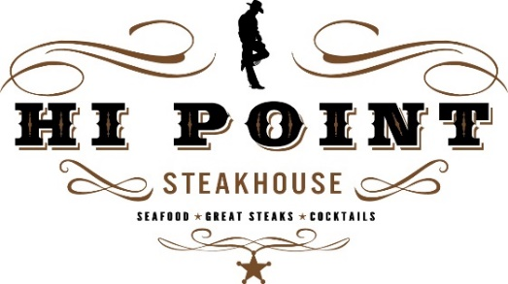
Now Hiring:

Bussers & Dishwashers
Duties include but not limited to clearing and resetting tables in a neat and timely manner, working with, and assisting other team members, washing, and putting away dishes, and completing end of shift duties and other various jobs tasks.

Hi Point Steakhouse is an upscale supper club located in Ridgeway offering flexible hours, and a team atmosphere.
Call us 608-924-2819 or apply on-line at hipointsteakhouse.com.

